Project 11: IR Remote Control Smart Car
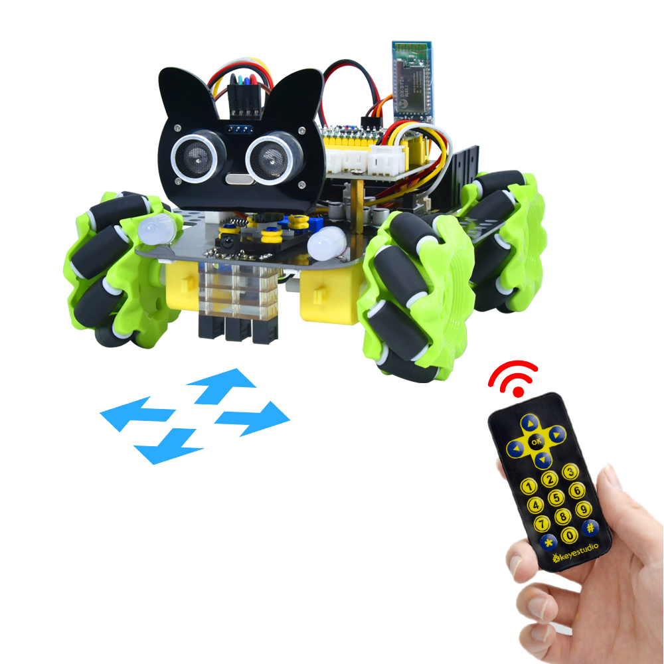

1. Description

In this project, we will work to control the car using an IR remote control.

- Flow Diagram
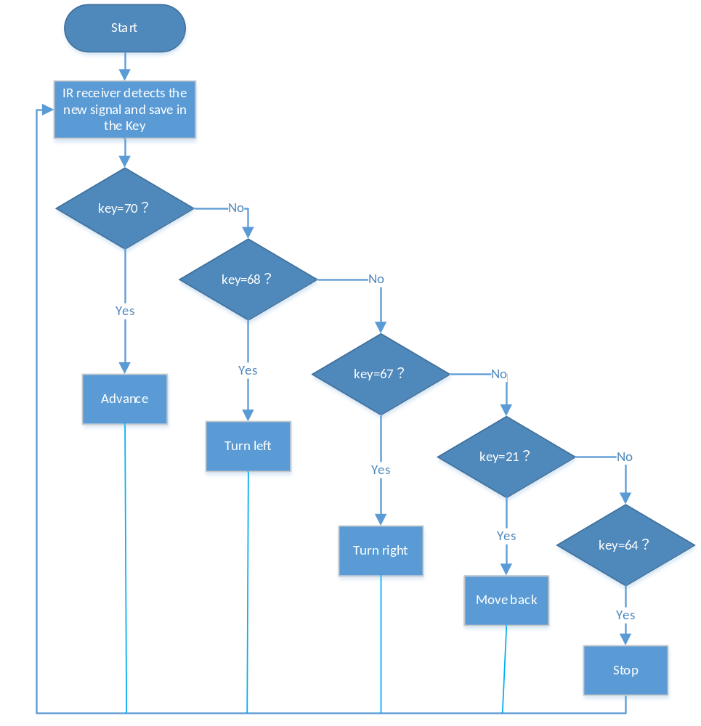

3. Test Code
/*
Keyestudio 4WD Mecanum Robot for Pico
lesson 11
IRremote Control Robot
http://www.keyestudio.com
*/
#include "MecanumCar_v2.h"
mecanumCar mecanumCar(20, 21); //sda-->20,scl-->21

/****Introduce IR Remote Control header file***/
#include "ir.h"

IR IRreceive(6);//IR receiver is connected to GP6

void setup()
{
mecanumCar.Init(); //Initialize the seven-color LED and motor drive
}

void loop() {
int key = IRreceive.getKey();
if (key != -1) {
Serial.println(key);
switch (key)
{
case 64: mecanumCar.Stop(); break; //Stop
case 70: mecanumCar.Advance(); break; //Advance
case 21: mecanumCar.Back(); break; //Move back
case 68: mecanumCar.Turn_Left(); break; //Turn left
case 67: mecanumCar.Turn_Right(); break; //Turn right
}
}
}

4.Test Result

Uploading the test code and powering up. When we press the button on the remote control, the car moves forward, then, the car turns left, , the car moves back, , the car turns right, , the car stops.

5. Code Explanation

switch (key)  {  case num: ...... break;  } | The switch statement, used with case, executes the statement after case when the variable in parentheses is the value after case
case 64: mecanumCar.Stop(); | The car will stop
case 70: mecanumCar.Advance(); | The car will go forward
case 21: mecanumCar.Back(); | The car will move back
case 68: mecanumCar.Turn_Left(); | The car will turn left
case 67: mecanumCar.Turn_Right(); | The car will turn right

